DELF Junior A2
This course is recommended for children in Year 5-6 and/or who have previously sat the DELF A1 exam. However, all students are welcome to apply by completing the written task below.
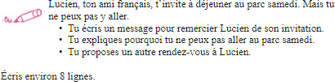

Your text :

